**IBM Data Science Business Case**

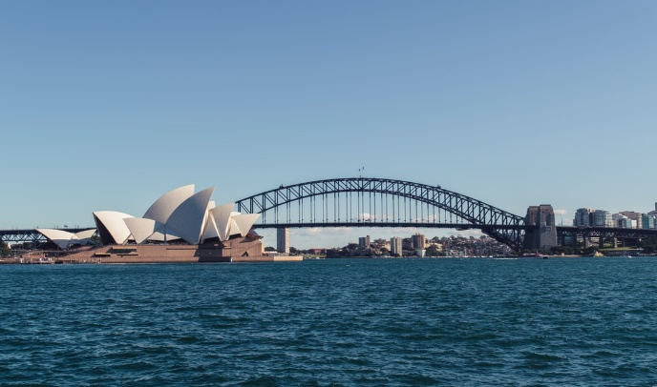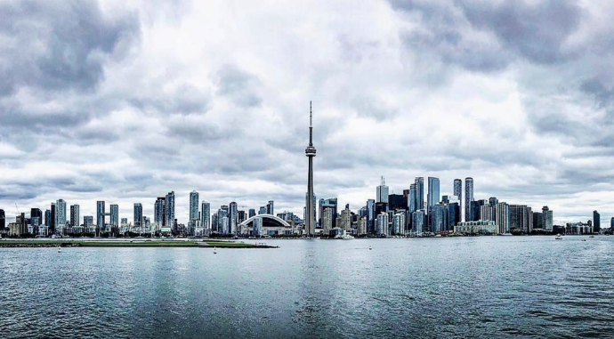

VS

**Project**

Canada is beautiful country with some of the nicest people in the world. Toronto, one of the counrty’s biggest cities is also the financial centre and therefore is a great place to emergrate to for professional work. This poses a problem though as the people looking to live in Toronto may have differening living criteria due to age, profession and wage. This defines the purpose of this case to find and define the different parts of Toronto and if possible, find a place that is most similar to my current city of Sydney for a person similar to myself, a young professional.

**Data**

The case study will be conducted using foursquare data as per the previous weeks tasks. Foursquare allows for data gathering on many different factors including businesses and landmarks in order to understand how people move through the real world. With the data aqaired from the platform a clustering approach shall be used to compare the two cities using a K means approach.